Date:
Document checked by:
Patient ID checked by:

New Patient Registration Form

Please complete this confidential questionnaire (one for each member of the family to be registered with the practice).

Please complete in BLOCK CAPITALS and tick the boxes as appropriate.

If you have newly arrived in this country, please bring your passport to confirm your date of birth and entitlement to NHS treatment.
Yes
No

Patient Details:
Title: | Full Name: |  | Date of Birth | Gender
Mr / Mrs / Miss / Ms / Other  (please circle) | Forename:  Middle Name:  Surname:  Previous Surname: |  | ____ / ____ / _______  dd/mm/yyyy | Female  Male  Other  (please tick)
NHS Number: |  | Marital Status:  (please tick) |  | Single  Married  Civil Partnership  Divorced  Separated  Widowed
Next of Kin: | Name and Contact Details:  Relationship:
Place and Country of Birth:

Contact Details:
Full Address & Postcode: | Contact Numbers:
Address:  Postcode: | Mobile:  Home:  Work:  Email:

PLEASE NOTE: YOU ARE RESPONSIBLE FOR KEEPING US INFORMED OF ANY CHANGES TO YOUR CONTACT DETAILS AS SOON AS POSSIBLE – PARTICULARLY IF YOU CHANGE YOUR MOBILE PHONE NUMBER.

Consent to contact:
You may be contacted by text message (SMS) for the following:
1) To inform you about medical matters
2) To re-arrange an appointment
3) To send you reminders

If you give consent to receiving texts, then please tick YES. If you do not consent to receiving texts, please tick NO.

Additional Details:
Refugee status: (please CIRCLE) | Religion: | Occupation: | School: (if currently a student)
• Refugee
• Asylum Seeker
Origin country:

Date entered UK:

Ethnicity: (Please select one)
Asian, Asian Welsh or Asian British | • Indian  • Pakistani  • Bangladeshi  • Chinese  • Any other Asian background
Black, Black Welsh, Black British, Caribbean or African | • Caribbean  • African  • Any other Black, Black British, or Caribbean background
Mixed or multiple ethnic groups | • White and Black Caribbean  • White and Black African  • White and Asian  • Any other mixed or multiple ethnic background
White | • Welsh, English, Scottish, Northern Irish or British  • Irish  • Gypsy or Irish Traveller  • Any other white background
Other ethnic group | • Arab  • Any other ethnic group

Language:
Main Spoken Language: | English Speaker | Welsh Speaker | Interpreter Required?
 | Yes /No | Yes /No | Yes /No

Previous Doctor:
If you have changed GPs more than once within the last year, please provide the names of the practices you registered with and respective dates:
Doctor/Practice Name: Dates (from-to):
Address:

Postcode:

Preferred chemist: (please tick)
Buckley:
- Allied
- Rowlands
Mold:
- Speeds
- Hughes
- Boots
- Tesco
ELECTRONIC PRESCRIBING SERVICE

From August 2025 our surgery went live with the Electronic Prescription Service (EPS). We therefore ask that you nominate a pharmacy of your choice to receive your prescriptions, which allows them to be sent electronically. You can change or cancel your nomination at any time by speaking to a receptionist. Pharmacies in Buckley are: Allied/Rowlands; pharmacies in Mold are: Speeds/Hughes/Boots/Tesco

Declaration: I would/would not (delete as appropriate) like to nominate a pharmacy for EPS. I nominate ________________________________ as my chosen pharmacy for dispensing of my prescriptions issued by the NHS Electronic Prescription Service.

Signed: _______________________________________ Date: __________________________________________

Healthy Behaviour:
Height: (in cm)  _____________ cm |  | Weight: (in kg)  ____________ kg | Blood Pressure  (Please take your BP at a pharmacy or at home)  _______/ ________
Smoking Status: (tick) |  | Exercise: | Alcohol:
Non-smoker |  | How often do you exercise? | How would you describe your alcohol consumption? (tick) | How much alcohol do you drink per week?  (One unit = 1 small glass of wine, a single measure of spirits or a ½ pint of beer)  No. of units per week: _______
Current Smoker |  | How often do you exercise? | How would you describe your alcohol consumption? (tick)
Ex-Smoker |  | No. times per week:  Type(s) of exercise? | - Teetotaller  - Light drinker  - Moderate drinker  - Heavy drinker  - Ex-drinker
Electronic Cigarettes |  | No. times per week:  Type(s) of exercise?
Consumption per week: |  | No. times per week:  Type(s) of exercise?

If you are a smoker and want to stop, please contact the smoking cessation services below: | If you would like some support with your diet or maintaining a healthy weight, please visit the Health Board webpage below: | If you would like some advice or support to reduce your drinking, please visit the Drinkaware webpage below:
Free Local Service www.HelpMeQuit.wales  0800 085 2219 | https://bcuhb.nhs. wales/health-advice/help-with-my-weight/ | www.drinkaware.co.uk

Medical History: (Please provide details & dates where possible)
Current/ongoing/past diagnoses & illnesses: |  | Current/ongoing/past operations/procedures:
Please provide a summary from your previous practice
Current Medication(s) (please list):
Please provide a copy of your repeat medication slip
Family History |  | Immunisation History | (provide date if possible)
Please tick if there are any serious diseases affecting your close relatives (parents/siblings):  - Diabetes  - Heart Disease  - Cancer  - Angina  - Epilepsy  - Lung Disease  - High Blood Pressure  - Asthma  - Stroke  - Thyroid Disorder  - Other (please specify): | Indicate family member and age at time of diagnosis: | Baby Imms course  0-12m
 | Indicate family member and age at time of diagnosis: | Pre-school booster
 | Indicate family member and age at time of diagnosis: | German Measles
 | Indicate family member and age at time of diagnosis: | BCG
 | Indicate family member and age at time of diagnosis: | Whooping Cough/ Pertussis
 | Indicate family member and age at time of diagnosis: | MenaCWY
 | Indicate family member and age at time of diagnosis: | HPV
 | Indicate family member and age at time of diagnosis: | Shingles
 | Indicate family member and age at time of diagnosis: | Seasonal immunisations (flu, fluenz, pneumo, RSV
Allergies:
(Please give details of your allergies, along with reactions & severities)

Women Only: (Please provide a summary from your previous practice if possible)
Last smear: | In surgery /hosp? | Result of smear? | Current contraception:  (if used) | Last mammogram:

Specialised Needs:

Please detail below any specific needs you have so the practice can ensure they are identified and accommodated by taking appropriate action:

Veteran Status | Impairments
Yes / No | (#F59)  Hearing loss: | (#F49) Visual impairment: | (#z567) Speech Impairment: | Physical Disability:
Date Left service: | Yes/No | Yes/No | Yes/No | Yes/No
Disabilities | Physical: Mental:
Are you a carer? Yes/No |  |  | Do you have a carer? Yes/No
Details of person requiring care:  Name:  D.O.B:  Relationship to you:  Registered at this practice? Y/N |  |  | Details of carer:  Name:  D.O.B:  Relationship to you:  Registered at this practice? Y/N  Contact no:
As a carer you may not know what help and information you may be entitled to.  NEWCIS may be able to assist you with this. |  |  | NEWCIS  Corlan Unit 3 Mold Business Park  Wrexham Road  Mold, CH7 1XP  Tel No: 01352 744055  Email: flintshire@newcis.org.uk  Website: www.carers.org/local/wales/flintshire

We are a Dispensing Practice for patients who are outside of the catchment area of a local pharmacy (only):
Do you live in any of the areas listed below? |  | Eligible for dispensing:
- Cadole  - Cilcain  - Coed Talon  - Eryrys  - Graianrhyd  - Gwernaffield  - Gwernymynydd  - Hendre  - Higher Kinnerton  - Leeswood  - Llanferres  - Llong | - Loggerheads  - Maeshafyn  - Mynydd Du  - Nannerch  - Nercwys  - Padeswood  - Pantymwyn  - Pontblyddyn  - Potybodkin  - Rhosesmor  - Rhydymwyn  - Tafarn Y Gelyn  - Treuddyn | If you live in one of the listed areas, as a dispensing practice we can dispense your medication from our dispensary at our Mold surgery. Regulations only allow us to offer this service to patients registered with us who live more than 1 mile from their nearest pharmacy and who live in a rural area.  If you would like the practice to dispense your medication, please sign and date the consent details below.
(For more information about the services we offer please see our website: www.bradleys.practice.co.uk)
I would / would not (please delete as appropriate), like the practice to dispense my medication.
I confirm that I live more than 1 mile (approx 1.6 kms) from my nearest pharmacy, and I provide consent to Bradley’s Practice to dispense medicines and appliances to me. I will confirm where I would like to pick up my medications (Mold or Buckley surgery) each time I request an item.

Patient Name: |  | Signature:
D.O.B: |  | Date:



CONSENT TO SHARE INFORMATION WITH APPOINTED THIRD-PARTY PERSON
(Optional – complete only if you wish a third party to speak on your behalf)
Bradley’s Practice
Buckley Medical Centre
Tel: 0345 900 7851
Email: admin.w00076@wales.nhs.uk
Date: _______________________________

Patient Details: |  | Third-Party Person Details:
Full Name: |  | Full Name:
Date of Birth: |  | Relationship to patient:
Address: |  | Address:
Contact No: |  | Contact No:

I (PRINT NAME) __________________________________________ hereby give consent for the above-named third-party person to have access to the medical records and personal details held about me by the practice, and for members of the practice staff to discuss my healthcare needs with the same named person.

This consent relates to FULL/PARTIAL ACCESS (delete as appropriate) to my medical records.
[Where permission is restricted to partial access, please tick the specific areas you DO NOT wish the named third party to have access]:

Medication/prescriptions
Test results
Appointments
Requests for information
SMS text (if alternative number provided)
Other (please specify:

I understand that this consent will remain active INDEFINITELY and if I wish to remove or restrict the above-named third-party person’s access to my medical records, I should inform the practice in writing. I also understand that a copy of this document will be held on my medical record indefinitely.

PATIENT SIGNATURE

Signed: _______________________________________ Date: __________________________________________

THIRD PARTY DECLARATION (for named third party to fill in below)

I (PRINT NAME) ___________________________________ hereby agree to treat any information that I receive in relation to the above-named patient’s medical records with confidentiality. I agree NOT to disclose any information to another third party without full consent, and any information I am provided with will be used in the patient’s best interest.

Signed: _______________________________________ Date: __________________________________________
Bradley’s Practice Lifestyle Advice

At Bradley’s we believe prevention is better than cure.

5 Pillars of Health

Healthy living will reduce your risk of heart disease, high blood pressure and stroke, type 2 diabetes, some cancers, breathing problems and mental illness. It will also increase your life expectancy. A healthy lifestyle gives better outcomes than any medication available.

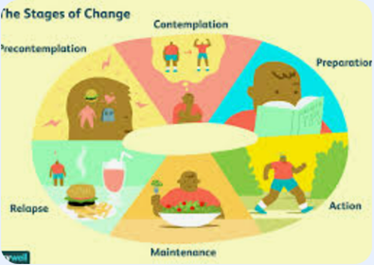

Yes, I’m ready to make a change…. https://www.nhs.uk/live-well/
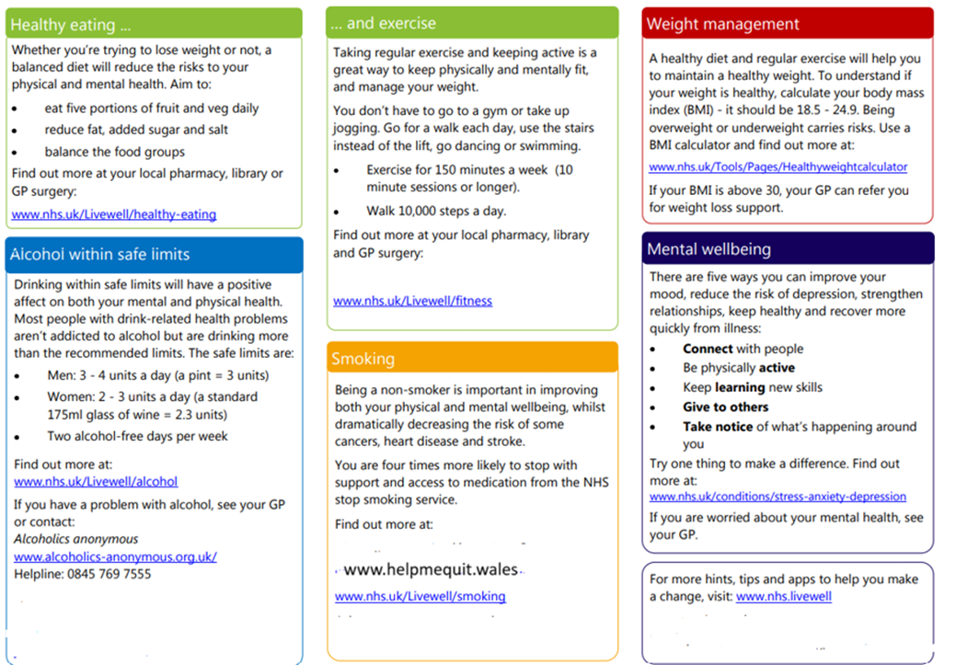


HelpMeQuit.Wales | www.Drinkaware.co.uk | https://bcuhb.nhs.wales/health-advice/help-with-my-weight/

Free apps
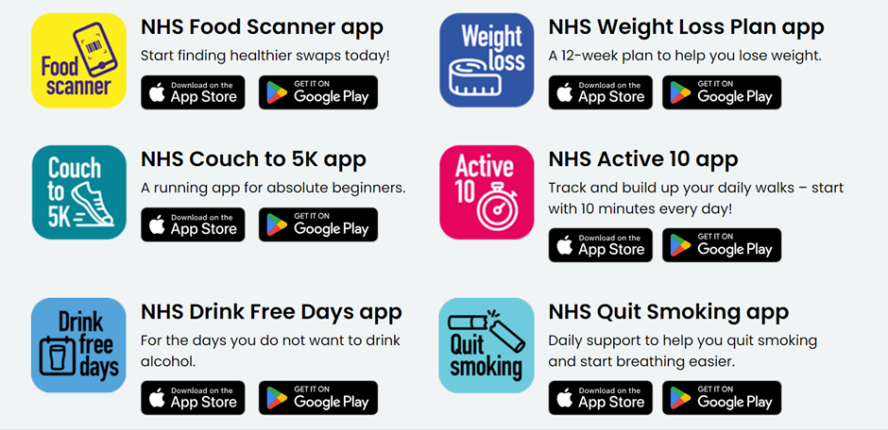
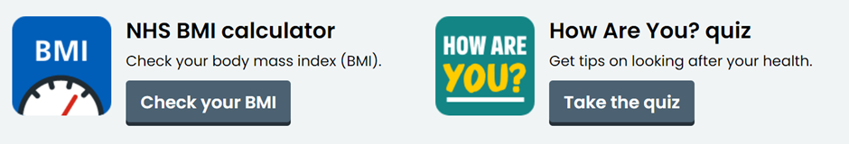

Other services available
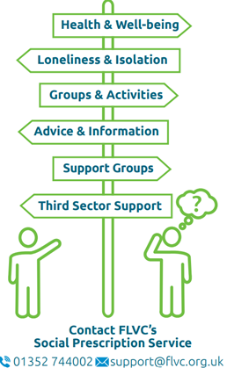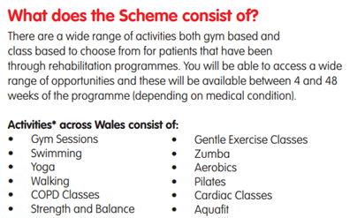

Ask your GP for a referral

